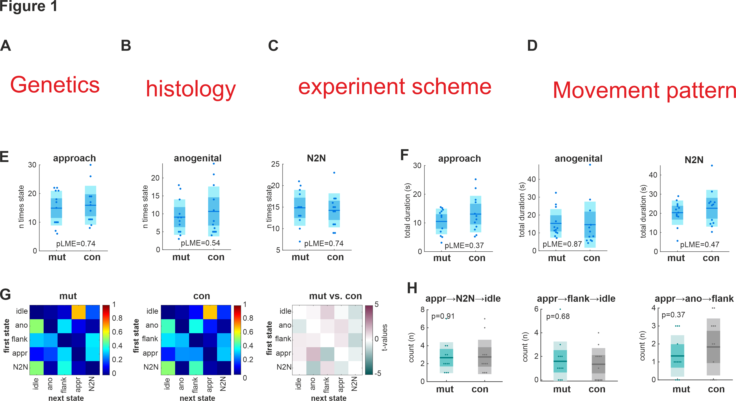

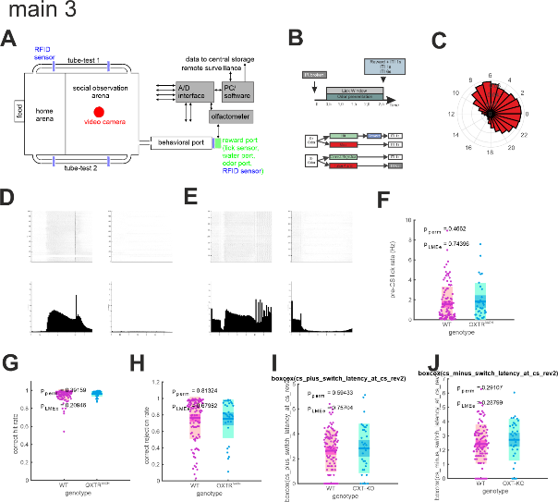

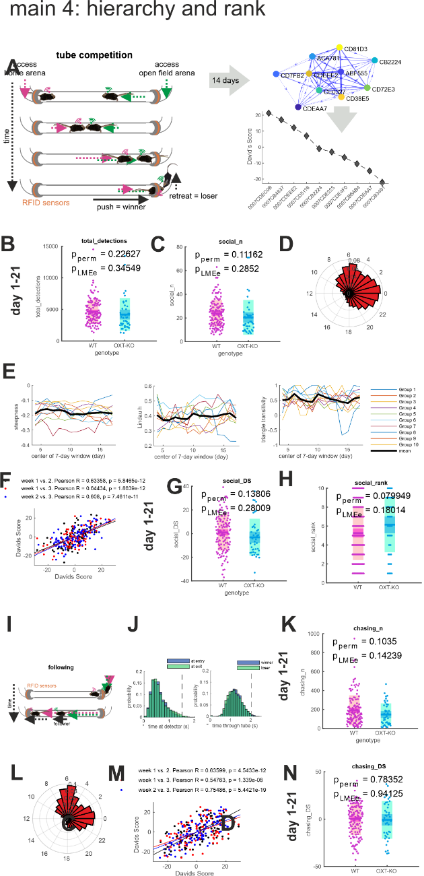

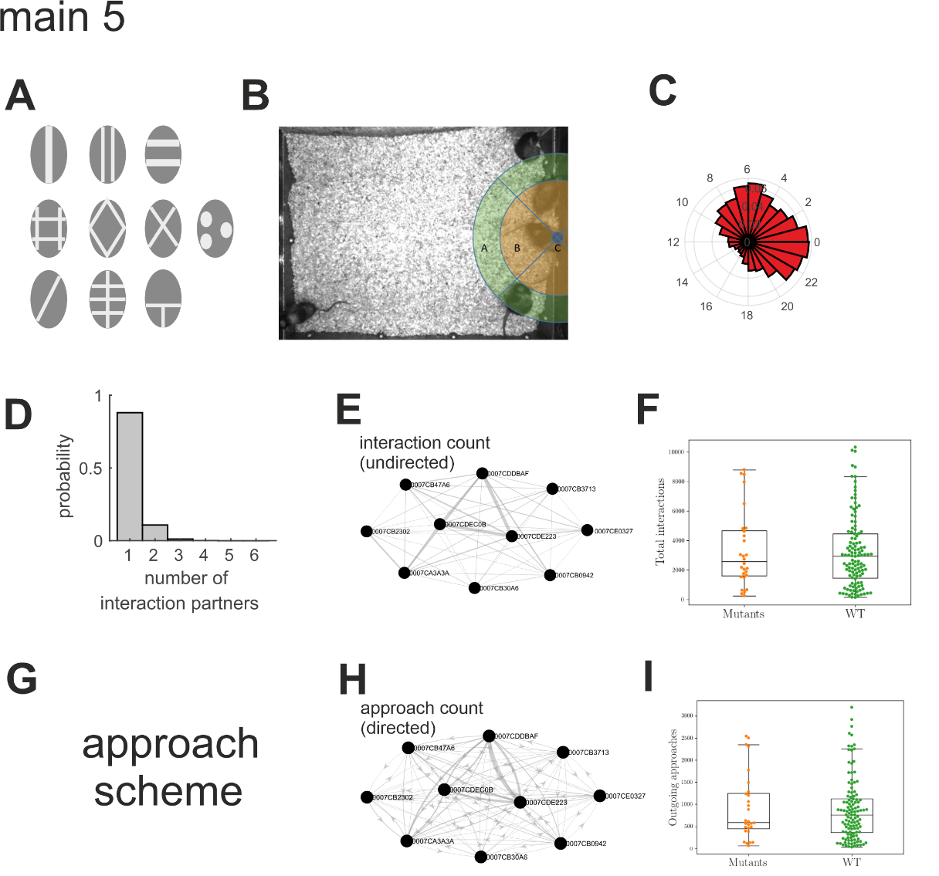

**Main 6**

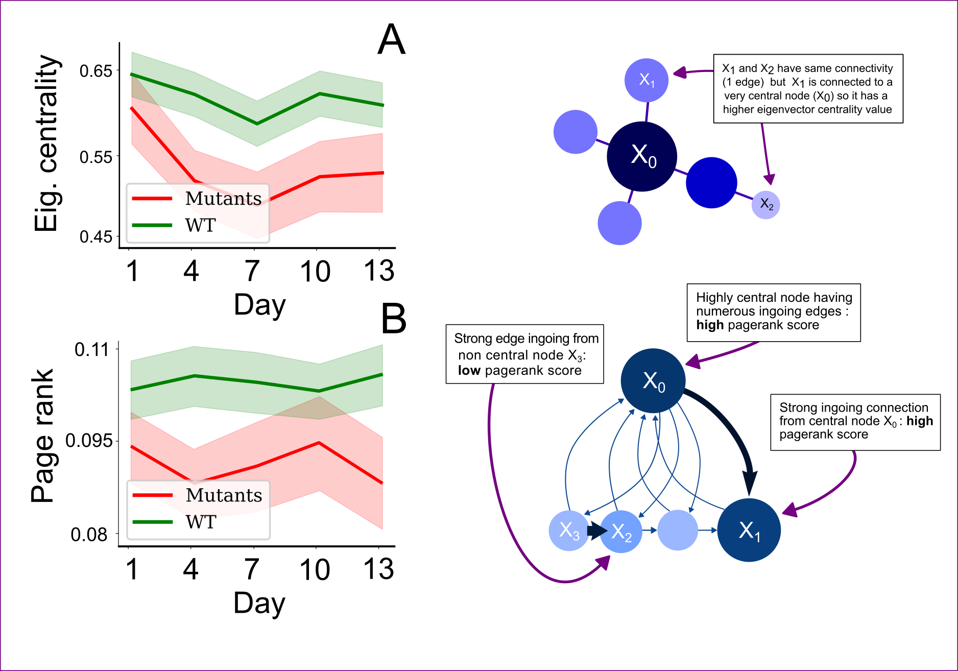

**Figure 6: Centrality measurements:** Graph theoretical measurements of centrality, averaged over all animals as a function of time. Each point in the left hand side figures corresponds to mean values obtained by averaging over the interaction graphs from the 16 different cohorts. The interaction graphs were constructed by summing the number of events between mice over three days. The shaded areas represent the standard error. **A)** Shows the average eigenvector centrality for WT mice (green) and mutants (red) as a function of time. It is a measure for undirected graphs, which we compute for the graphs of interaction number between mice. The corresponding right hand side schematic shows the important factors that influence the value of the eigenvector centrality **B)** Shows the pagerank score, which is a measure for directed graphs that we computed using the graphs of averaged approaches between mice. The page rank is influenced by the number of ingoing connections to a node, or by the number of strong ingoing connections to highly connected nodes. An intuition for how this measure behaves is given in the right hand side depiction.

**Figure 7: RC presentation**



**Figure 8: RC features**



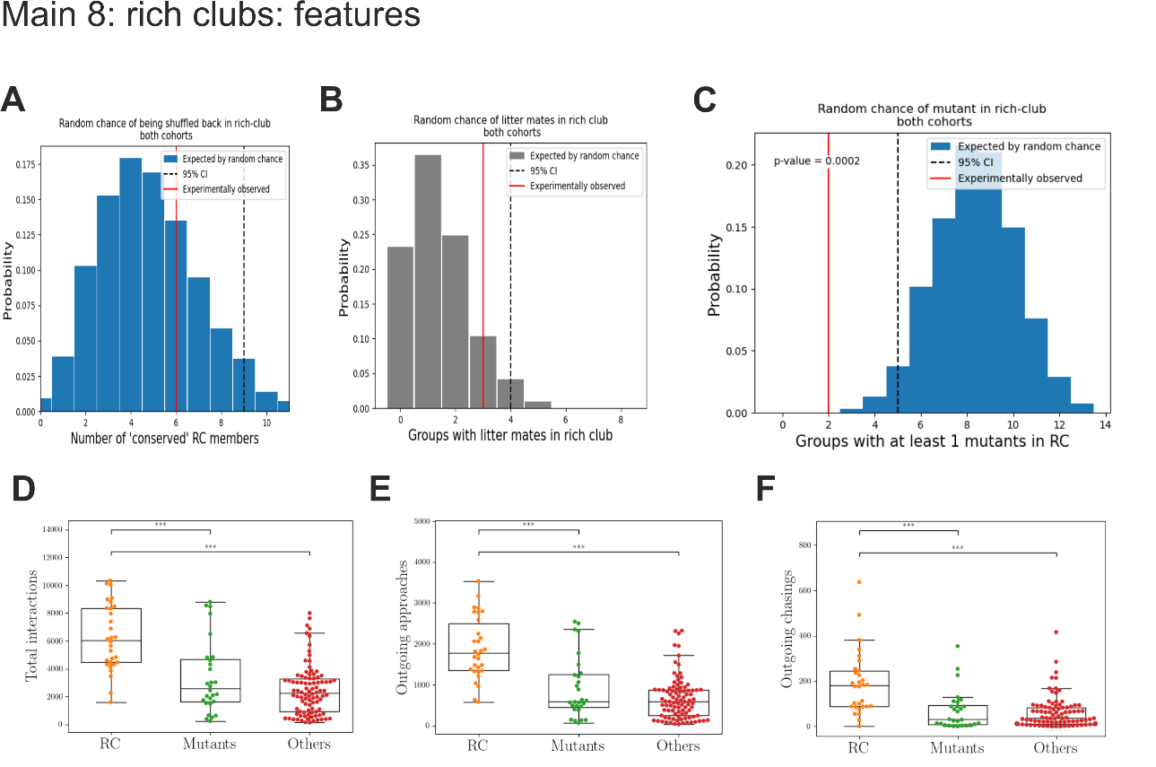

**Main 10**

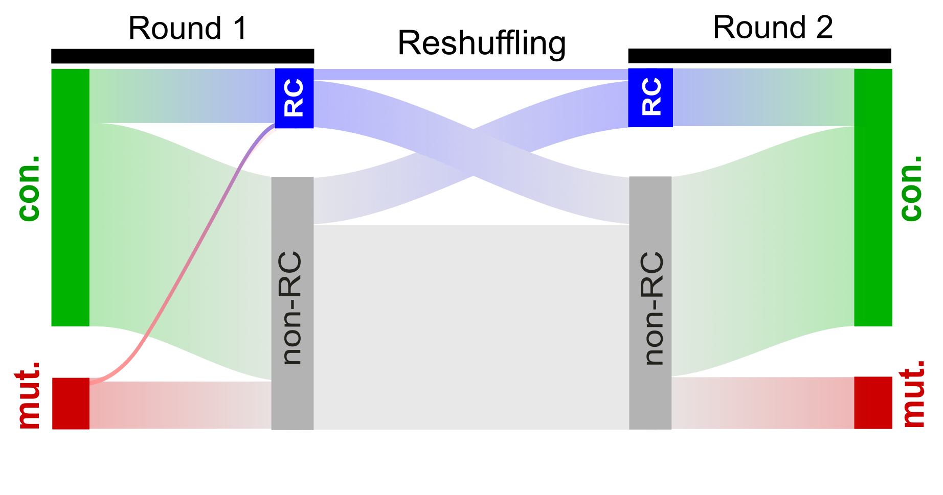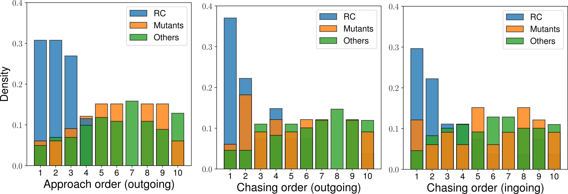

**Main 11**

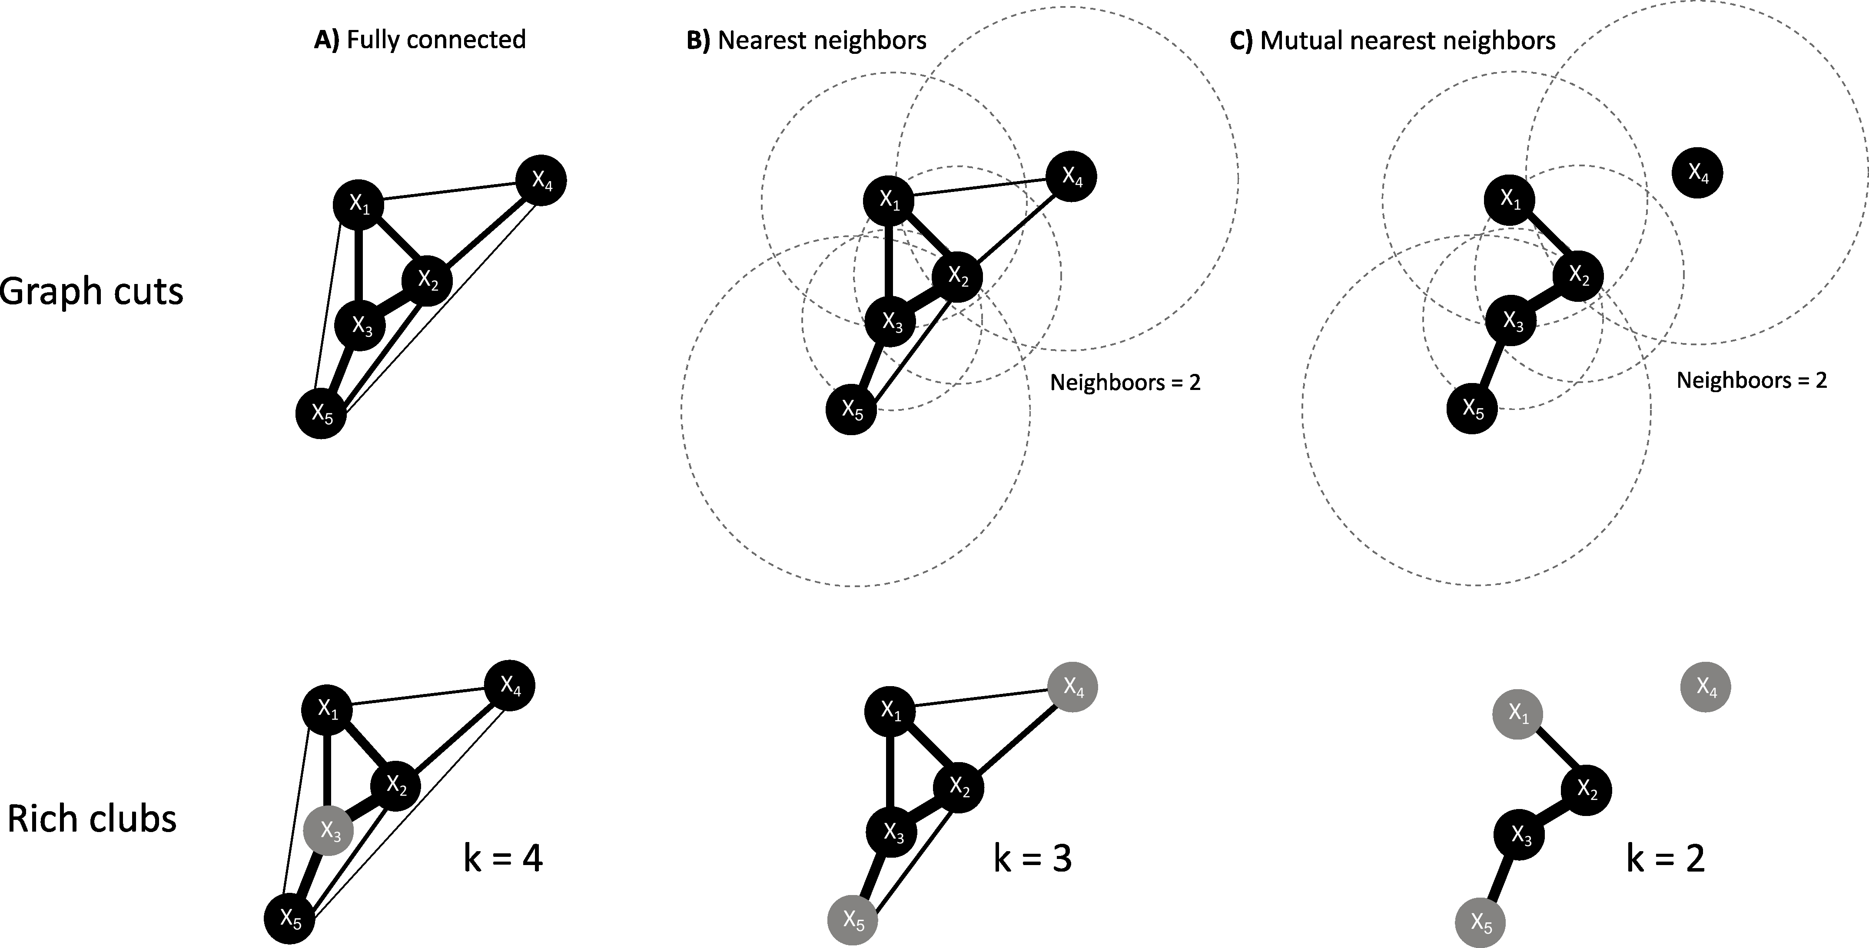

**Figure 10: Example of mutual nearest neighbors bars graph cut.** The top part of the figure shows the different steps going from the original graph **(A)**, the graph obtained by keeping edges only between nearest neighbors of second order **(B)** to the final graph **(C)** that only preserves the edges from **(B)** for nodes that are mutual nearest neighbors (2nd order) of each other. For each node, a dashed circle show the distance to its 2nd nearest neighbor. If two nodes are mutually within their circles, they are mutual nearest neighbors. The bottom part of the figure shows the different rich clubs that are obtained as a function of the graph-cut method used. In the original graph (fully connected), almost all nodes are members of a rich club of degree 4 except for node $x_{3}$. Using nearest neighbors of 2nd order, one finds a rich club of order 3 composed of nodes $x_{1}$, $x_{2}$, and $x_{3}$, whereas with mutual nearest neighbors only the nodes $x_{2}$, and $x_{3}$ are part of a rich club of degree 2.